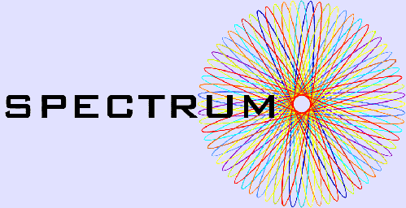

Study of Policies regarding Economic instruments Complementing Transport Regulation and the Undertaking of physical Measures (SPECTRUM)

SPECTRUM NEWSLETTER

Welcome to the 1st issue of the SPECTRUM Newsletter
November 2003

Dear Reader,

The SPECTRUM Newsletter will be distributed to policy and transport authorities, transport operators and managers, user groups, academics and others. Please forward this free newsletter to others you think might find it interesting and useful.

Please address all comments to the newsletter editor Torben Holvad (e-mail torben.holvad@tsu.ox.ac.uk)

In this issue:
- SPECTRUM Introduction
- Partners
- Scientific approach
- Outputs
- Case studies
- Further information
- Next issue

- SPECTRUM introduction

SPECTRUM is a project funded by the EU as part of Fifth Framework Programme. The main objective of the SPECTRUM project is to: "develop a theoretically sound framework for defining combinations of economic instruments, regulatory and physical measures in reaching the broad aims set by transport and other relevant policies" in terms of efficiency and equity. As there is a tension between managing the transport system in such a way as to minimise social costs and simultaneously managing the system to meet increased demand, the work of SPECTRUM will address this problem by looking at the potential effects of using either individual instruments, complementary packages of instruments, or the consequences of substituting instruments, in managing the transport system. The project is scheduled to finish by August 2005.

- Partners

Institute for Transport Studies, University of Leeds (ITS) (project co-ordinator) www.its.leeds.ac.uk
University of Antwerp (UFSIA) www.ua.ac.be
Transport studies unit, University of Oxford (OXFJQ) www.tsu.ox.ac.uk
Technical Research Centre of Finland (VTT) www.vtt.fi
University of Technology Vienna (TUV-IVV) www.ivv.tuwien.ac.at
University of Las Palmas (EIET) www.ulpgc.es
University of Budapest (BUTE) www.kgazd.bme.hu
University of Leuven (KU LEUVEN) www.kuleuven.ac.be
Institute of Transport Economics, Oslo (TOI) www.toi.no
Institute for System Integration Units (ISIS) www.isis-it.com
University of Gdansk (UG) www.ekonom.univ.gda.pl

- Scientific approach

The problem that SPECTRUM is seeking to resolve is multi-dimensional, covering transport and wider policy objectives, urban and inter-urban contexts, passengers and freight, all modes of transport, addressing both high and low level impacts and a broad range of transport instruments. The scientific approach here has been designed to effectively structure this complex problem into three main Work Areas.

In the light of the current state of the art, it is inevitable that the project has to start by developing an overall high level framework for determining operational indicators for objectives, treating the various dimensions of equity, assessing policy measures in a consistent way, considering their transferability and, above all, identifying the attributes of instruments for integration in a package, synergy, complementarity and substitution. The first Work Area has been designed to develop the high level framework and this will be described within the first publicly available SPECTRUM deliverable due to be released in Summer 2003.

Two parallel analysis and assessment Work Areas will simultaneously address the interurban and urban contexts specifically. These will take elements from the initial design of the framework and following a review of the impacts of individual measures, form packages of instruments. Case studies then explore empirical outputs that would be produced by the packages. Assessments of the impacts then feed back to the high level framework and (together with results from a theoretical study of synergies and impact measurement guidance) form the final comprehensive framework.

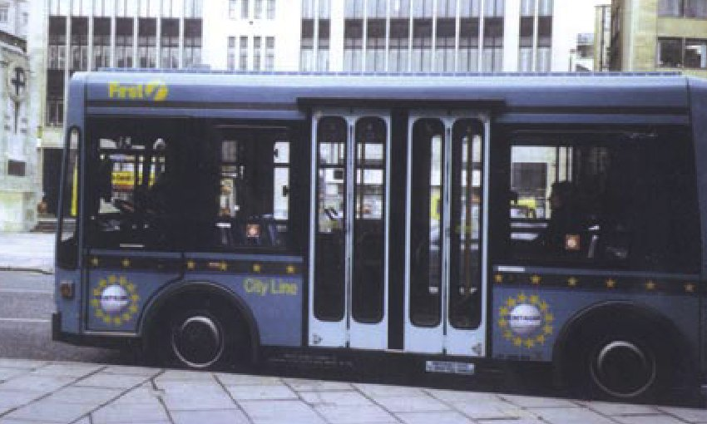
Battery electric bus in the UK

- Outputs

SPECTRUM will provide a number of timely outputs, including:

- A theoretically sound framework for analysing the trade-off between objectives and identifying optimal combinations of instruments to achieve them. This will cover all modes, passenger and freight transport for both the urban and inter-urban context. Impacts will be indicated for equity, freight, passengers, safety and externalities as appropriate. The framework will be based on welfare economics and cost-benefit analysis and take into account impacts that cannot be monetised with current knowledge in a consistent way.

- Analysis and assessment of transport packages. Quantified evidence on the use of alternative instruments in managing urban or inter-urban capacity and the likely practical impacts of different approaches. This will involve a minimum of three case studies in the urban context and four case studies relating to the inter-urban context.

- Generalisation. Information for target users on the synthesised evidence and transferability of alternative transport management packages across the broader urban/inter-urban spectrum and their wider social impact. Transferability will be indicated for range of contexts including similar/non-similar sites and accession countries.

- Guidance and recommendations. Concrete suggestions for complementing and substituting economic measures with regulation and other instruments will be produced. Recommendations will be linked to identified EU policy priorities

- Case studies

Inter-urban case studies

Uni-modal local scale case studies
- Air: Madrid Barajas Airport (Spain) with focus on passengers
- Rail: East Coat Main Line (UK) with focus on passengers
- Road: Road Corridor IV (Hungary) with focus on passengers and freight
- Sea: Port of Antwerp (Belgium) with focus on freight

Multi-modal national/regional scale
- London-Brussels-Paris Corridor(s) (passengers)
- Norway (passengers)

European scale
- Passenger and Freight Analysis at a European level

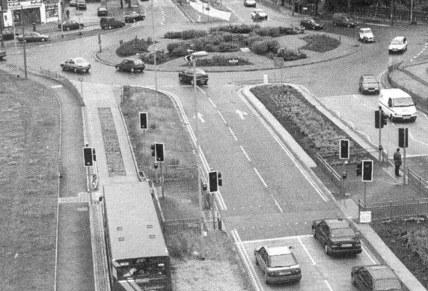
Leeds guided bus approaching roundabout

Urban case studies

- Two multimodal case studies, which take a strategic viewpoint of the transport system and hence use strategic models (FREDRIK/RETRO and SPM, with the latter being highly strategic) - (Leeds and Oslo)
- Two road sector case studies, which represent the road sector in greater detail than in the multimodal case studies, and hence use a more detailed tactical model SATURN – Leeds and York.

- SPECTRUM workshops

Two high profile project dissemination workshops will be organised towards the end of the project. These workshops will serve to disseminate the analysis and assessment results and launch the framework and transferability outputs to a wider audience. One of these will be based in Poland and will also provide a means of knowledge and expertise sharing between consortium members from Accession countries and those from the European community. It is intended that this will be open to a wider audience than the immediate project consortium and therefore promote a wider knowledge share with academics, government and industry. The second dissemination workshop will be held in Brussels. Further details about the workshops will be made available during 2004.

- Further information

Please address any further enquiries on the scope of the SPECTRUM project to the project co-ordinator, Dr Susan Grant-Muller, sgmuller@ITS.leeds.ac.uk

SPECTRUM information is also available from http://www.its.leeds.ac.uk/research/index.html

- Next issue

The next issue of the SPECTRUM Newsletter will be available by March 2003. It is envisaged that it will contain articles on:
- Framework for defining packages of economic, regulatory and physical instruments
- Update from case studies
- Synergies and conflicts of transport instrument packages
- Measurement and treatment of impacts
- Interviews with target users

Quick Links

- SPECTRUM Introduction
- Partners
- Scientific approach
- Outputs

- Case studies
- SPECTRUM workshops
- Further information
- Next issue

This Newsletter is produced by the SPECTRUM Consortium. The SPECTRUM project is an Accompanying Measure funded by the European Commission under its Research, Technological Development and Demonstration Framework Programme for Transport.

Further information can be found on www.cordis.lu. Further information on SPECTRUM is available from the Project Co-ordinator Dr. Susan Grant-Muller (Institute of Transport Studies, University of Leeds, e-mail: sgmuller@its.leeds.ac.uk

