INTELLIGENT SPEED ADAPTATION – EFFECTS ON DRIVING Behaviour

Mari Päätalo, Harri Peltola and Mikko Kallio

VTT – Building and transport
P.O. Box 1800, FIN-02044 VTT, Finland
Tel. +358 9 456 6205, fax. +358 9 464 850, e-mail. Mari.Paatalo@vtt.fi

The objective was to answer the following questions:
- How do the drivers experience the different types of ISA: Informative, compulsory and recording?
- How does the ISA affect driving behaviour?
- What are the differences between the different types of ISA systems?

In a field study 24 subjects drove the instrumented car with route guidance and Intelligent Speed Adaptation (ISA). Every subject drove the same route four times. The route included different types of traffic environment with different speed limits. The speed limits were 40, 60, 70 and 80 kilometres per hour and the environment varied from motorway to residential area.

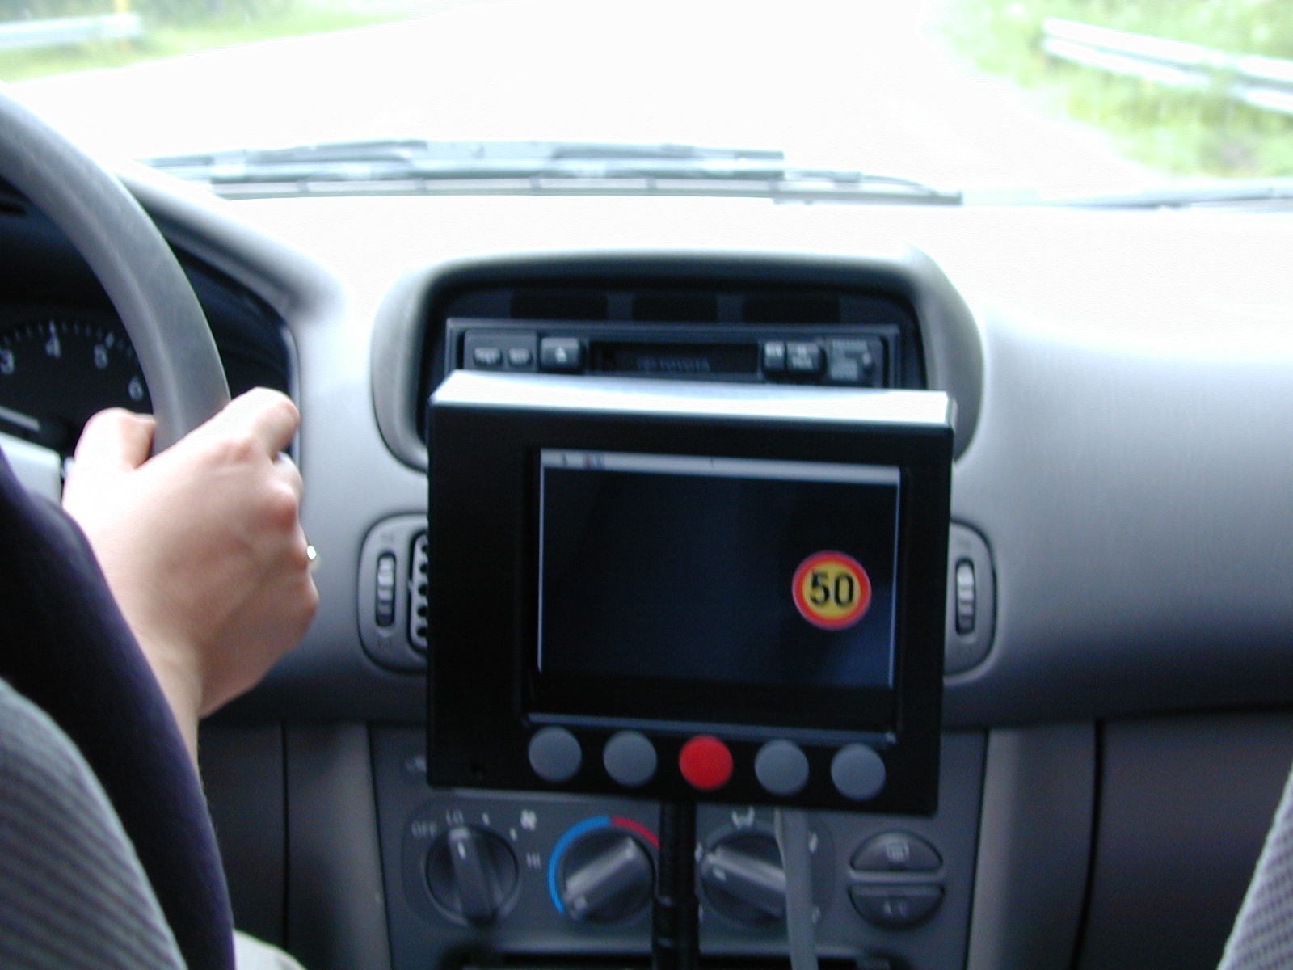
Figure 1. The instrumented car. The driver’s view of the system.

The Instrumented car

The instrumented vehicle is a normal passenger car with concealed measuring equipment that is based on the Global Positioning System (GPS). The car ‘knows’ the current speed limit by the location.

The subjects were 30 to 50 years old. They were owners of a Toyota Corolla, with manual gears, which was the same type of vehicle used as the instrumented car. The subjects were selected randomly from the owners of cars similar to the instrumented car.

Testing method

The subjects drove the route four times, getting different information each time: One of the times the route was driven only with route guidance, which was used as a base level. The other three times driver used different types of ISA. Each driver used the systems in a different order to minimize the influence of learning. The ISA systems were an informing system, a compulsory system and a recording system.

The route guidance was shown with arrows before an intersection. If the route straightened over the intersection and there was no possibility of misunderstanding, the arrow was not shown. If there was a possibility of misunderstanding, the name of the place or the street was displayed at the monitor, which was the same name as seen on traffic signs.
When a new message was displayed on the monitor, a beep sound attracted the driver’s attention to the monitor. This way the driver could concentrate on driving without looking at the monitor all the time.

In order to obtain as reliable results as possible, the drivers were not told that their traffic behaviour was being recorded, but only that the research objective wasto test the usability of the systems.

The subjects drove the route alone, i.e. without the presence of the experimenter. The route was shown to the driver from the map before the first drive. The map was given to the driver in case there were any problems following the route. The drivers were also provided with cell phones and the experimenter’s cell phone number in case of any problems. Each driver was encouraged to rely on the route guidance, and only to use the aid in a problem situation. The difficulties in finding the right route were checked from the GPS data.

The system modes in the test comprised.

- Only the route guidance. The driver was only given the direction arrows at the intersections. No information about the current speed limit.
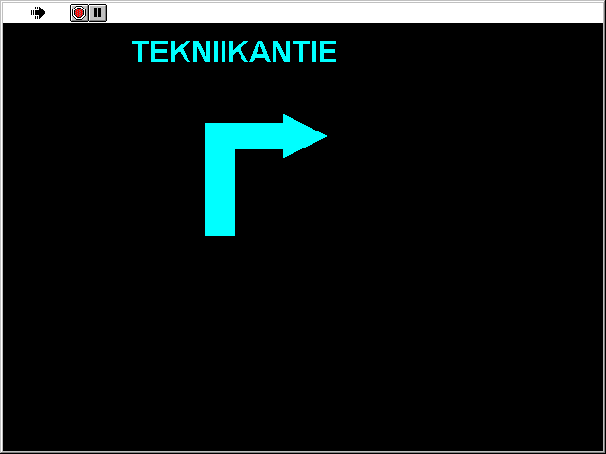
Figure 2. The route guidance system. Above the arrow was the name of the road or the place if there was a possibility of misunderstanding.
- Informative system. In addition to the route guidance, the driver was given the information on current speed limit on the monitor. If he drove faster, the system voice signal said – Speed offence and the same text was displayed on the monitor. The voice signal was repeated every ten seconds until the speed dropped to within the limit. Despite the feedback, the driver was free to drive at the speed he wanted.

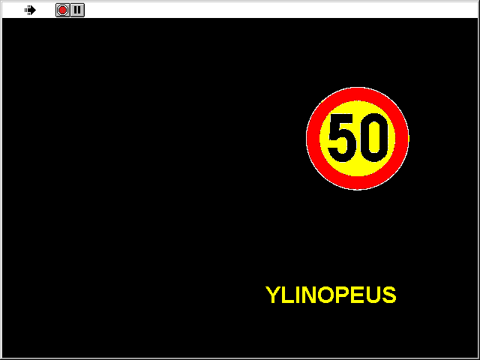
Figure 3. The informative system. The yellow text means ‘SPEED OFFENCE’ and was shown if the driver was speeding.
- Compulsory system. In addition to the route guidance, the current speed limit was shown on the monitor. When the vehicle reached the current speed limit, a yellow spot was displayed to inform the driver of the situation. At the same time, the block on the gas pedal was activated, so the car could not exceed the speed limit.

. 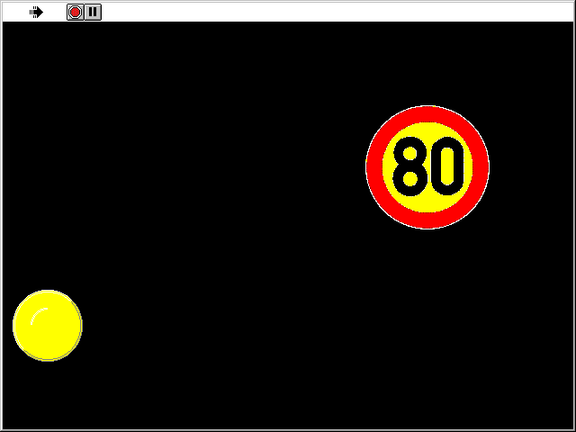
Figure 4. The compulsory system. The yellow spot on the monitor indicates that the vehicle’s speed has reached the current speed limit.
- Recording system. The driver was aware that his speed behaviour was being recorded. The diagram on the monitor shows the driver how muchhe has been speeding. The system gives information on the length of time the driver has been speeding from the beginning of the drive. The speeding offences are categoried in three different groups.
- Speed offence less than 5 km/h
- Speed offence from 5 to 10 km/h
- Speed offence over 10 km/h
To avoid too much information on the monitor, the diagram was not shown at the same time as the route guidance arrow. The drivers were told that the speed limit offence diagram would only be used by the driver himself and by the experimenter.

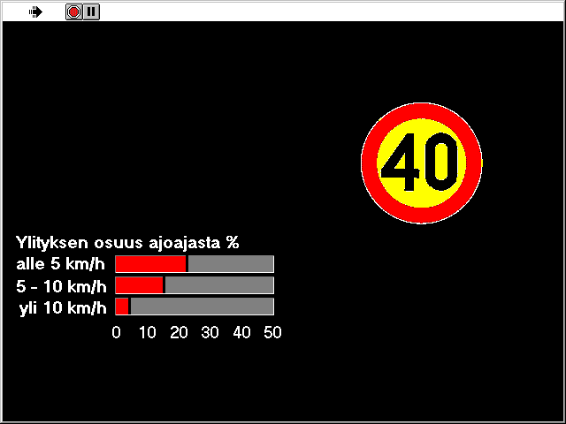
Figure 5. The recording system. The diagram shows the length of time from the beginning of the route that the driver has been speeding.

Results

The route was about 17.6 kilometres long. The average number of times per minute the drivers used the driving the route is shown in Figure 6. It can be seen that there was no significant difference in the driving times.
Figure 6. The average driving time with different systems.

 | Mean
System | Overall driving speed | Driving speed
Only the route guidance | 42.6 | 46.5
Informing system | 39.4 | 43.7
Compulsory system | 39.2 | 43.1
Recording system | 40.6 | 44.5
Table 1. The overall driving speed and driving speed without stops.
The driving speeds are shown in Table XX. The overall driving speed with only the route guidance was 42.6 km/h and when the stops were taken away from the travel time, the average driving speed was 46.5 km/h. The stops were defined as situations where the vehicle’s speed was 1 km/h or lower.

Speeding with different ISAs
The time the drivers speeded with different system modes is shown in Figure 6. Every ISA system was recorded to reduce the time speeding from the base level. The time speeding at the base level was 9 minutes With the compulsory system the time speeding was only 2.3 minutes, which is 6.7 minutes less than the base level. The informing system was also an effective speed reducer with 3.5 minutes reduction. With the recorded system the time reduction was 3,3minutes.

Figure 7. Time speeding with the different systems.

The different speed limit areas
One interesting point was to study whether speed adaptation would be especially effective for some type of traffic information. Figure 7 a shows that the length of time speeding was greatest in the 40 and 80 km/h speed limit area. The biggest reduction due to the ISA systems was recorded in the same speed limits.

Figure 8 a, b, c and d. The influence of ISA on speeding in different speed limit areas.

The speed limit |  | Change in time in speeding with ISA-system (percentage units)
 | Route guidance | Informing system | Compulsory system | Recording system
40 | 58,6 % | -37,3 % | -43,7 % | -22,9 %
50 | 21,2 % | -13,8 % | -16,6 % | -9,6 %
60 | 32,7 % | -17,0 % | 15,5 % | -16,1 %
70 | 29,3 % | -19,1 % | -24,9 % | -14,2 %
80 | 51,9 % | -30,0 % | -45,1 % | -21,2 %
Table 2. The base level and change of speeded time with different ISAs.

Interviews

After every test drive the driver answered questions about the system. Most of the questions were the same every time and they were based on WORKLOAD questions. The aim was to find out how the driver felt about each system and what their attitude would be to the systems in everyday use. In particular, the aim was to determine the possible differences between the systems. The results of the interviews are shown in Figure 9.

Figure 9. The results of the interviews
The drivers seemed to find the mental demand of driving highest in the compulsory and recording system. 25 % of the subjects found ‘required attention and concentration’ to be high (answers from 7 to 9) with these systems.
It is interesting to note that drivers felt high time pressure with the compulsory system; 20 % of the drivers felt that they had to hurry (from 7 to 9) with the compulsory system, while for the other systems the same percentage was near 4.

In addition, the effort needed, the frustration and the insecurity were highest with the compulsory system.

Figure 10. Influence of the systems on driving and safety.
Figure 11. Acceptability and traffic safety improvement.

Free comments
In the interview forms the subjects completed after every test drive, the opportunity for free comments was also given. The comments of the drivers were documented as much as possible.
The drivers were very satisfied with the route guidance. Some mentioned some faults in the messages; either the messages were given too early or too late. Every driver thought that the system would be very useful especially in unfamiliar places.
In every ISA system, the information of the speed limit was found to be very advantageous. Some drivers, who used the mode with only the route guidance after ISA system(s), even mentioned that they missed the speed limit information.

The informative system with the voice signal was found to be annoying. The drivers thought that every 10 seconds was far too often. A message ‘sometimes’ was said to be welcome. A good situation for a message would be when the speed limit changes, for example, when leaving the motorway and entering a built up area. The drivers also thought that the informative system was too rigid, the caution was given immediately when the speed was over the speed limit. Some flexibility was agreeable.

The compulsory system was considered very irritating and even dangerous. The drivers were worried about situations when there would be a need to get out of the way. The drivers also thought that the compulsory system makes other car drivers drive very close thus likely to cause more rear-end collisions.
Despite the irritation, the compulsory system was mentioned to be effective in speed management. The drivers asked if the system could be switched off, and admitted that if they could switch off the system, they would probably not use it.

The recording system was considered desirable. The drivers were interested in their own speed behaviour. Some drivers suggested that the speed information could be seen ‘sometimes’, or example, you could look at the amount of your speeding at the end of the day.

Willingness to pay

The subjects were asked how much they would pay for the system if it were voluntary and chargeable. There were no optional answers given, so the answers were all based on what were the subjects’ ideas of the price for the system. No hint was given from the experimenter. The answers varied from 15 euros to 2 500 euros. Therefore, strong conclusions from this cannot be drawn, but again we can study the differences between the groups. 19 subjects (79%) were ready to pay some amount of money. For the recording system 16 subjects (67%) named a price. The informing system got 13 (54%) subjects to name a price, and for the compulsory system the number of subjects was 11 (45 %). The willingness to pay follows the results of other interview results, which indicate the recording system is the most acceptable ISA-system.

Price, Euros | Only the route guidance | Informing system | Compulsory system | Recording system
no price named | 5 | 11 | 13 | 8
1 to 170 | 6 | 4 | 3 | 8
170 to 830 | 11 | 8 | 8 | 8
830 to 1700 | 0 | 1
over 1700 | 2
All | 24 | 24 | 24 | 24
Table 3. Willingness to pay. The price the drivers named they would pay for the system.

Conclusions

The driving time differences from the base level to the different ISA systems were not significant. However, ISA systems seemed to be effective in reducing speeding, especially excessive speeding.
The most effective speed reducer seemed to be the compulsory system. The informing system was also effective and some reduction was also seen with the recording system.

The problem is that the acceptability of ISA systems was just the opposite. The compulsory system was rejected, and the informing system was not found very enjoyable. Nevertheless, the drivers approved this one more, because they felt that they still had control of their car, even though the voice signal was considered to be annoying. In the WORKLOAD interviews and in the free comments the drivers were very pleased with the extra information. The recording system was the most popular. One interesting point is how effective the recording system would be in the future, in everyday use. The recording system was tested without any mentioned consequences – the speed offence result was only indicated to the driver himself and the experimenter.

