Pedestrian and Bicycling Simulation at the University of Iowa
Presented by Prof Joe Kearney, University of Iowa
Date: Tuesday 12th September 2017
Time: 12.00-13.00
Location: rm1.11 Institute for Transport Studies, University of Leeds

Abstract
Virtual environment technology offers tremendous potential for safely and systematically investigating risk factors associated with the interactions of pedestrians, bicyclists, and vehicles, and to study interventions to mitigate these risks. Recent technological advances in displays, tracking systems, and simulation software platforms have dramatically reduced the cost and difficulty of creating highly immersive, interactive pedestrian simulators. This includes large screen systems and systems that use head-mounted display technology.
This talk will present research on pedestrian and bicycling simulation at the Hank Virtual Environments Lab, University of Iowa. The presentation will cover simulator design and describe a set of studies examining how various factors influence road crossing behaviour including: age, texting, vehicle-to-pedestrian (V2P) communications, peer influence, and lighting conditions. Discussion will focus on the potential and limits of simulation for understanding the causes of pedestrian and bicycling crashes and methods to reduce them.
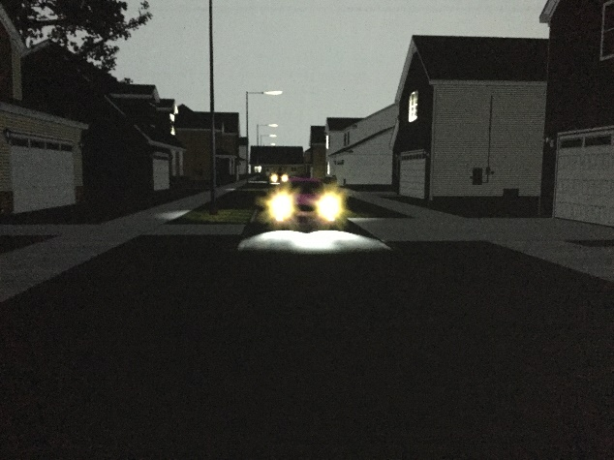
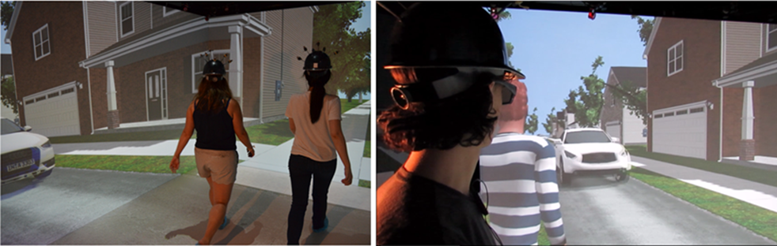
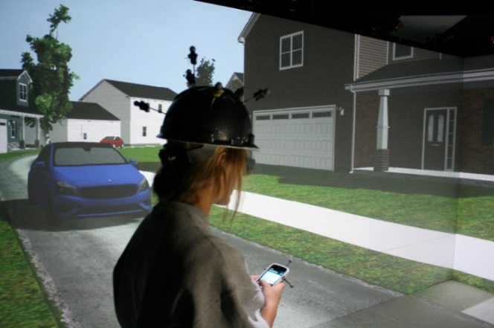
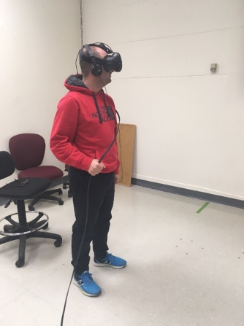
HTC Vive pedestrian simulator
Crossing with a computer-generated agent
Texting with and without P2V alerts and warnings
Nighttime with and without adaptive headlights

Joint action

Bio
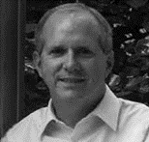
Joseph Kearney received a B.A. in psychology from the University of Minnesota, an M.A. in psychology from the University of Texas, and an M.S. and Ph. D. in computer science from the University of Minnesota. He is a Professor of Computer Science at the University of Iowa. Kearney co-directs the Hank Virtual Environments Lab that houses virtual bicycling and pedestrian simulators and is an Associate Director of the Safer-Sim UTC. His research focuses on how virtual environments can be used as laboratories for the study of human perception, action, and decision making with special focus on how children and adults cross traffic-filled roadways on a bike or on foot.

