Being on the map:
the new iconographies of power over European space

Ole B. Jensen, Department of Development and Planning, Aalborg University
Tim Richardson, Department of Town and Regional Planning, University of Sheffield

Address for correspondence:
Ole B. Jensen
Department of Development and Planning
Aalborg University
Fibigerstraede 11
DK-9220 Aalborg
Denmark

tel: +45 9635 8285
fax: +45 9815 3537
e-mail: obj@i4.auc.dk

Being on the map:
the new iconographies of power over European space

Abstract
This paper explores the representation of European space in images, and the significance of these images in building and reproducing policy discourses of European space. Landmark and less well known images of European spatial relations are discussed, from representations of trans-European infrastructure networks to the iconic 'bananas' and 'grapes', and through to the new science of infographics, which explicitly attempts to articulate new European spatial concepts such as polycentricity in image form.

Images are understood as elements of an emerging transnational spatial policy discourse, and so are analysed in the context of contestation over meanings, played out in policy debates, in documentation and in other practices of spatial planning. In particular we concentrate on how images are used together with textual references and discussions to form a persuasive component of spatial discourse. We therefore analyse these representations of space as contested, rather than as the outputs of rational spatial analysis. The aim is to reveal the underlying rationales of different framings of space and spatial relations, leading to insights into the ways in which such images are playing an increasingly important role in foregrounding certain ways of thinking about European space and mobility whilst bracketing others.

Our analysis suggests that whilst iconic representations of European space articulate an apparently unified view of European development, they also embody major unresolved tensions at the heart of the spatial development strategy, in particular between competing configurations of urban and regional development and mobility. Depending on their interpretation, the images can be seen as capturing the tensions between flows and places, and between underlying rationalities of cohesion and competition. Overall, the paper argues that whilst the use of images in EU spatial policy discourse succeeds in strongly visioning a polycentric Europe of flows, it also (perhaps unintentionally) reproduces the uncertainties, conflicts and tensions which surround this vision. The paper concludes with a discussion of how such use of images can contribute to the formation of a European identity.

Authors’ note
An earlier version of this paper was presented at the XVI AESOP Congress 2002, Volos, Greece.

No scientific discipline exists without first inventing a visual and written language which allows it to break with its confusing past (Bruno Latour: Drawing Things Together).

Maps, stripped of all elements of fantasy and religious belief, as well as of any sign of the experiences involved in their production, had become abstract and strictly functional systems for the factual ordering of phenomena in space. The science of map projection, and techniques of cadastral surveying, made them mathematically rigorous depictions (David Harvey: The Condition of Postmodernity).

When maps are drawn, emotions run high (Dutch National Spatial Planning Agency: Spatial Perspectives in Europe).

1. Introduction

This paper explores how the representation of European space in images has played a part in building and reproducing policy discourses of European space. Landmark and less well known images of European spatial relations are discussed, ranging from representations of trans-European infrastructure networks to the iconic 'bananas' and 'grapes', and through to the new science of infographics, which explicitly attempts to articulate new European spatial concepts such as polycentricity in image form. In doing this, we hope to draw together and build on some of the observations of previous research which have pointed to the significance of images in European spatial policy making (particularly Kunzmann, 1996, Williams, 1996a,b, Faludi, 2000).

Our use of the term ‘iconography’ is a way of framing concerted attempts to construct policy icons using images that capture and distil critical ideas about European space in ways that can be communicable to a policy audience as well as to a wider citizenship. We are particularly interested in the ways that such images can be seen as building blocks for a potential European identity, and here we attempt to draw out the implications for identity building of the particular ideas and values which are reproduced in the emerging imagery. This investigation into the visual representations of EU spatial policy does not constitute a comprehensive semiotic analysis. Even so our analysis suggests that whilst iconic representations of European space articulate an apparently unified vision of European spatial development, of a ‘Europe of flows’ (Hajer 2000), they also reproduce the major uncertainties, conflicts and unresolved tensions at the heart of the spatial development strategy. These tensions centre on competing configurations of urban and regional development and mobility. Depending on their interpretation, the images can be seen as capturing the tensions between flows and places, and between underlying rationalities of cohesion and competition.

The structure of the paper is as follows. First we outline a tentative conceptual framework for understanding the different ways that spatial images can play a part in policy making. We then analyse some of the major examples of European spatial policy maps, focusing specifically on the use of proposals maps in the trans-European transport network (TEN) and successive drafts of the European Spatial Development Perspective (ESDP). Our contribution to analysis of these fields is to add a new layer of analytical exploration focusing on maps and images. We discuss how, in the new spatial policy discourse, the imagery of European space is changing, as explicit maps of policy proposals are replaced by impressionist representations of policy ideas. Finally, we draw things together by discussing how these images contribute to the construction of a new policy discourse of European space in ways that are instructive on the power relations operating at this level.

2. Conceptualising the meaning of images

Images are understood as elements of an emerging transnational spatial policy discourse, and so are analysed in the context of contestation over meanings, played out in policy debates, in documentation and in other practices of spatial planning. In particular we concentrate on how images are used, together with textual references and discussions, to form a persuasive component of spatial discourse. We therefore analyse these representations of space as being contested, rather than as the outputs of rational spatial analysis. The aim is to reveal the underlying rationales of different framings of space and spatial relations, leading to insights into the ways that such images are playing an increasingly important role in foregrounding certain ways of thinking about European space and mobility whilst bracketing others.

But how can we ‘break the code’ in terms of analysing such images? Here we make use of the approach that we have previously applied to the analysis of EU spatial planning (Jensen & Richardson, 2001, Richardson & Jensen, 2000). Accordingly ways of framing space in these policy discourses demand an understanding of both words and images as they are articulated by social agents within specific institutional settings in order to bring about a strategy expressing a certain power-rationality configuration. In this sense we perceive these images in the broadest sense to be part of the ‘language’ and vocabulary used to frame European spatial development – a sort of ‘textual mapping’. In this paper we will consider in particular two different aspects of images which help in drawing out their different uses in policy making. Firstly we are interested in how images contain representations of space in varying degrees of detail. Secondly we are interested in how images may act to frame and reproduce policy metaphors, without necessarily being tied in their content to the representation of particular dimensions of physical space.

For the purposes of analysis, spatial images can be divided into two categories, one concerning the referentiality of images, and one concerning maps as mental constructs (Dematteis, 2000). The latter approach can again be subdivided into a heuristic and a de-constructive approach to maps. The de-constructive approach deals with consolidated images and traces the unspoken premises of common thought and explores alternative meanings (Dematteis, 2000: 49).

We are all familiar with the territorial representations of more or less realism that we call maps. From the geography schoolbooks picturing the nation state territory to the iconic diagram of the London tube we have learned to deal with such visual representations of space and place. But what is a map more precisely? A map can be understood as a cultural text (Harley, 1996: 432), meaning that one has to engage in an interpretative activity in terms of its analysis. The cultural significance of maps lies in their ability to capture and frame ideas about space, and carry them from one mind to another, in a field of discursive struggles over meaning and interpretation. Mapping and imaging are therefore techniques of power in that they capture and frame certain ideas, relations, realities and potentials whilst excluding others. In doing this, they also mask the interests that bring them into being (Wood, 1993: 95):

It is, of course, an illusion: there is nothing natural about a map. It is a cultural artefact, a cumulation of choices made among choices every one of which reveals a value: not the world, but a slice of a piece of the world; not nature but a slant on it; not innocent, but loaded with intentions and purposes; not directly, but through a glass; not straight, but mediated by words and other signs; not, in a word, as it is, but in … code (Wood, 1993: 108).

As Latour (1990) argues, mapping means ‘drawing things together’ in the sense that diverse semantic fields immediately can be brought into contact:

Realms of reality that seem far apart (mechanics, economics, marketing, scientific organization of work) are inches apart, once flattened out onto the same surface (Latour, 1990: 54).

In this way maps act as a focusing device (Wood, 1993: 117). In the words of Dematteis, as they ‘connect together a quantity of ‘superficial’ evidence, they mark changes and problems, suggest hypotheses, challenge consolidated images’ (Dematteis, 2000: 71). This is partly because the process of map making involves activities of selection, omission, simplification, classification, creation of hierarchies and symbolisation (Harley 1996:437). Furthermore de-constructing the map also means an epistemological shift from a strict reality-representation link towards seeing maps as inherently power laden (Harley, 1996). Thus the ‘cartographic rules’ in a sense resemble the Foucauldian ‘epistemes’ (Foucault, 1969/89) with certain rules of representation. But they also are rhetorical devices:

All maps are rhetorical texts ... All maps strive to frame their message in the context of an audience. All maps state an argument about the world and they are provisional in nature ... Indeed, the freedom of rhetorical manoeuvre in cartography is considerable: the mapmaker merely omits those features of the world that lie outside the purpose of the immediate discourse (Harley, 1996: 437).

Mapping is thus also a communicative event in the sense that we are dealing with both author subjects and institutions as well as audiences. But space can also be represented in ways which rely more on the use of metaphor than representation, where the graphical qualities of the image do not rely on an attempt to represent physical space in anything more than a notional manner. Many of the iconic spatial images in European spatial policy discourse (e.g. the reference to fruits or machines) have taken on a life beyond the original image that framed them. We need to think about how such spatial images combine visual graphics and concepts, and that these concepts often are metaphorical in their core. The essence of metaphor is understanding and experiencing one kind of thing in terms of another (Lakoff & Johnson, 1980: 5). Within social theory there is a very widespread use of metaphors for consciously and analytically describing social phenomena in terms of machines, living systems, legal orders, war, market places, games, theatres, and discourses (Rigney 2001). However, also social theory may import metaphors in a less reflective way, and thus make use of such ‘thinking devices’ without really critically appreciating it (Urry 2000). Thus spatial metaphors play a critical role in the formation of human knowledge, action and imagination and provide a quasi-logical framework of associations (Williams 1996a: 95). So the metaphors form a vital part of the 'spatial imaginary’ and refer to the processes of social spatialisation (Shields, 1992: 7):

Metaphors may create realities for us, especially social realities. A metaphor may thus be a guide for future action. Such actions will of course, fit the metaphor. This will, in turn, reinforce the power of the metaphor to make experience coherent. In this sense metaphors can be self-fulfilling prophecies (Lakoff & Johnson, 1980:156).

The metaphors of the European spatial planning discourse to be analysed here are in fact famous for their colourful and associative capacities. Notions of ‘blue bananas’, ‘bunches of grapes’ and ‘golden triangles’ (Williams, 1993), are ways of imposing certain qualities of these metaphors and excluding others and are thus an expression of a European spatial rhetoric (Williams, 1996b). Such a way of spatial framing can be labelled ‘framing with images’ (Faludi, 1996). According to such a perspective the images work by providing principles of spatial organisation that stick in planners’ minds, enticing them to act and assisting public dialogue (Faludi, 1996: 97). The London Green Belt, the Copenhagen Finger Plan, and the Dutch Green Heart are all examples of such ‘framing with images’ where a spatial policy discourse make use of powerful metaphors as well. Many people have never seen the original images which first articulated these concepts, but they retain some sense of the vision which lies behind them, capturing core values and spatial relations. Metaphors such as the blue banana carry powerful messages about the organisation of European space and economy as they become policy icons which take on a life beyond their graphic origin.

These analytical dimensions are significant for scrutinising the new field of European spatial policy making, which is clearly characterised by strong use of metaphorical imagery. Dematteis has pointed to a lack of theoretical and analytical depth in European spatial planning documents, in favour of extensive use of spatialised language and imagery that works at a more rhetorical level and aims to reach beyond the policy process into the public domain:

This theoretical and analytical weakness is reflected in the absence or near-absence of technical content in the planning and urban policy documents produced by the EU and by the Governments of its member states. The ample recourse to spatial language in these documents is largely rhetorical, not only in the general sense that the language of geographical space is in any case a sort of metaphorical code for talking about social issues and implicit political projects, but also in the stricter sense of an artifice designed to persuade (Dematteis, 2000: 70-71).

So EU spatial policy discourse, articulated through its images, maps and spatial metaphors, as well as many other devices, can be understood as contributing to an explicit political agenda. But these images also play a part in the more implicit political project of framing European identity in a new way, underpinned by a new consciousness about European space (Jensen, 2002).

Summing up, we are arguing for a critical focus on maps, images, and spatial metaphors as vital elements in the discursive framing of European space. In widening the ‘vocabulary’ of analysis from text to include graphical representations we aim to deepen our understanding of how spatial policy discourses work in power laden and rhetorical modes. In this way, we may bring to empirical analysis of spatial policy discourses some basic insights into the deep embeddedness of images and maps in textual representations, illustrating the powerful urge for ‘being on the map’.

3. Mapping European space – empirical examples

Shrinking Europe

One of the most striking examples of attempts to frame space in EU policies for planning and transport can be found in the agenda-setting work of the industrial lobby. Here we explore how a critical policy problem for European integration - the absence of adequate infrastructure to support the completion of the single market – was first framed in agenda-setting lobbying using spatial metaphors such as ‘missing links’ and ‘missing networks’, and was subsequently re-articulated in the consequent policy discourse of frictionless trans-European mobility in a more positive way: the solution of high speed infrastructure and a shrinking Europe (figure 1).

Advocacy for improvements in international infrastructure linkages as part of the single market programme can be found most explicitly in lobbying material produced by the European Round Table of Industrialists (ERT) in the 1980s (eg ERT 1984). The critical role of the ERT in shaping EU policy has been analysed elsewhere, for example by Green (1993), Cowles (1995) and Lemberg (1995), and attacked by environmental activists (eg A SEED, 1993). Through the lobbying activities of the ERT, we see the construction of a new policy discourse of European space and mobility as a result of concerted action by European industrialists.

The ERT has been described as ‘the spiritual progenitor of the 1992 process, and the single most powerful business group in Europe’ (Gardner, 1991: 48, see also Cowles, 1995). Endo (1999) points to the ERT as one of the few pressure groups able to actually change EU policy. Having defined the infrastructure problem in terms of missing international infrastructure links (ERT, 1984), the ERT next sought to set the agenda for action in Missing Networks - A European Challenge, proposals for the renewal of Europe’s infrastructure (ERT, 1991). The first level of action, based on the rethinking of spatial relations on a European scale, was to continue to deal with the problem of missing links. By 1991, however, the need for physical infrastructure improvements had extended eastwards, to encompass the new European orientation of the Central and Eastern European states, and had become more of a network view, as international corridors were identified.

The second level of action called for by the ERT was perhaps more far reaching in its scope. They called for a fundamental restructuring of institutions and practices in order to achieve the required pan-European transport perspective. The report goes beyond arguing for physical solutions - building new roads or railways - and states the need for new ways of conceptualising, decision making and financing trans-European networks. Here, then, was an explicit call for a EU policy response, rather than simply trans-national infrastructure project implementation. Building on the imagery of Missing Links, in Missing Networks, the ERT proposed not only new physical infrastructure, but also a shift in the mindset of politicians and policy-makers: ‘to think and rethink existing networks in specifically European spatial and economic terms’ (op.cit.).

The ERT propose a number of ways forward. Among these is the identification of ‘missing networks’ - new mechanisms for the planning and delivery of transport, which are needed to bridge the gaps between transport modes, and to deliver international infrastructure corridors - and the adoption of holistic, integrated approaches. The concept of ‘missing networks’ clearly expresses a problem to which the logical policy response would quickly become ‘trans-European networks’ (TENs).

Inherent in these metaphors is the quest for frictionless mobility (Hajer 2000, Urry 2000), in this case by removing the physical and institutional barriers to free movement across Europe. The shift from a problem of friction to a solution of free mobility, traceable in the emerging policy discourse, is powerfully articulated through another important spatial metaphor: ‘shrinking Europe’. The trans-European transport network contributes to an effect of shrinking European space by reducing journey times, and so reduces the barriers of time-space between European member states, regions, and cities. In Missing Links, the ERT graphically illustrated equivalent length journeys in the US and Europe, and identified the additional time delays caused in Europe by border crossings and inadequate infrastructure – the economic message was clear. The idea of a shrinking Europe has become a preoccupation of policy makers and analysts. Figure 1 demonstrates how the benefits of TENs are communicated graphically in the image of shrinking EU space. The image is based on detailed analysis, but the overall effect is powerfully rhetorical. In Europe 2000+ (CEC, 1994), a key Commission policy document setting out elements of its spatial vision, the image is accompanied by the text ‘Planned improvements will .. effectively bring regions closer together’.

[FIGURE 1 ABOUT HERE]

We turn now to the use of proposal maps in European spatial policy making. Proposals maps have been highly controversial, and have attracted political struggles that have tended to mask the actual policy issues at stake. We illustrate this by discussing how the proposals maps for trans-European transport networks in the early 1990s became the focus of intense lobbying which became separated from the debate over policy guidelines. This is followed by a discussion of the use of proposals maps in the drafting of the ESDP, illustrating how mapping policy proposals became so controversial that the final ESDP dispensed with them altogether, instead making use of maps depicting the results of spatial analysis. Thus in the struggles over proposals maps, we can see contestation over their meaning: are they intended as blueprints or as ‘target images’?

Trans-European Networks proposals maps: road network

The High Speed Rail (HSR) network master plan was published by the Commission as early as 1990 (CEC, 1990). It was not until several years later, following the Treaty on European Union that Karel van Miert (Transport Commissioner, 1989-95) set out the first Commission proposal for trans-European networks in the principal transport modes. This led to a Council Decision on the creation of separate trans-European networks in the areas of roads, combined transport and inland waterways. These separate network master plans were brought together in 1994 into a single, multi-modal proposal, incorporating road, rail, inland waterways, combined transport, seaports and airports, as well as information and management systems for the integrated network. The concept of the trans-European transport network was now properly institutionalised.

Policy development in the period after 1992 followed two parallel courses. One was the preparation of a policy / planning framework which would guide future decision-making on networks, individual corridors and projects. The other was the preparation of a series of outline plans for individual transport modes. The drawing up of master plans was increasingly influenced by lobbying from regions and member states on the inclusion (or otherwise) of particular lines on the maps. The succession of revised plans for each transport mode came to form a central focus to the development of policy, running parallel to development of policy guidelines.

Figure 2 shows one of the proposals maps for the trans-European road network. Here we can see a powerful image which depicts an apparently homogenous EU territory linked by a single transport network which seamlessly crosses the borders and natural barriers between member states. A series of existing and proposed links and corridors are identified, which represent physical space in a reasonably precise manner. As well as articulating the broader message of a mobile Europe, it allows actors operating at different spatial scales and representing different interests to ask questions such as ‘is our town on the map?’, and ‘will our commercial strategy be supported by the new infrastructure proposals’. In fact, the preparation of these maps reflected the playing out of EU, national and regional political, industrial and environmental interests. In the drawing up of this map, and the corresponding maps for other transport modes, several strategies can be identified. Perhaps the most apparent is the EU discourse of integration through the establishment of the networks. However the strategies of other actors did not fit so neatly into this harmonious view of European space. One example is the use of Tens by member states as a means of promoting their adopted national transport plans. The emerging maps can be interpreted as reflecting in large part the transport plans of individual member states, rather than a European view:

... where things went wrong in the first place was that the Commission then got in touch with each member state and asked them what they wanted and of course all they did was dust down all their old national plans from the shelves and put them in (Member of the European Parliament).

Later, regions and other local authorities would become more active in lobbying for the adoption of locally preferred schemes within the outline plans, but in the early 1990s member states carried out only limited consultations in developing their submissions to the Commission.

[FIGURE 2 ABOUT HERE]

The infrastructure lobby maintained a powerful hold at the EU level, as the proposals from member states and other bodies were filtered and assembled into network outline plans. The membership of one of the key decision making bodies illustrates the institutional power of this lobby. Proposals for the Trans-European Road Network (TERN), for example, were developed by the Motorway Working Group (MWG) of the Commission’s Transport Infrastructure Committee. Membership of this Group includes the Commission, member states, the European Conference of Ministers of Transport, and significantly a number of private sector interests including the European Round Table (ERT), the Association des Constructeurs Européens d’Automobile (ACEA), and the International Road Transport Union (IRU) (CEC, 1992). The overwhelming dominance of transport interests, and the infrastructure lobby, and the absence of environmental interests can be seen. It is difficult to imagine that such a committee could produce anything other than a solid case for progressing TERN. The decision making process adopted by the MWG is unclear, although they transformed national infrastructure ‘shopping lists’ into international network proposals. However, environmental criteria were not integrated into decision making although they were identified, in broad terms, in policy documents (Bina et al, 1995). The published proposals identify a network of corridors, but fail to set out the criteria used in their designation. It appears that the debate within this key decision making arena was largely political.

The importance of the European industrial lobby in the development of TERN was clearly recognised within the EU institutions, but perhaps seen more as a positive influence in achieving a pan-European perspective, counter to some of the more parochial lobbying:

We’re building a single market for Europe, we need a single European transport system to go with it, that system must be sustainable. But it’s got to be European, we can’t have national networks superimposed on each other and bad interconnections. And they’re the people building this stuff, and also they’re the people using it (European Commission official).

A feature of the preparation of outline plans was that, although the infrastructure lobby enjoyed a high level of access in decision-making, environmental organisations were never formally consulted. The Member States were expected by the Commission to represent their respective environmental interests (Frommer, 1992: 10, and European Commission official’s comments).

Given the above, it is not surprising that any comprehensive planning which might have taken place in the preparation of the outline plans was overshadowed by multi-level lobbying and political bargaining. What was launched as a grand European vision risked becoming an assemblage of local pet projects:

Oh yes. It was all terribly parochial, terribly parochial. I mean this isn’t really European planning this is all about out member states trying to get a bit of commission money for things they were going to do anyway, and local authorities trying to jump on the bandwagon. That’s really what was happening (European Commission official).

This high level of interest in TENs can be simply explained by the prospect of a new source of funding (the EU budget) for local or national projects at a time when finance was becoming difficult in the face of recession and increasing resistance to infrastructure development on environmental and social grounds. One interviewee explained this financial interest thus:

... And at that point ministers got involved, and said “well these are some maps and we want to put a bypass on there”. And then people start smelling money, so you get everyone coming along. Local authorities, they fail to get money out of national government, they haven’t got enough money in their own coffers, so they think they’re going to get money out of the Community. So everyone comes along lobbying to get their little pet schemes onto the TEN and the result is that you end up with, not a tight limited set of routes of importance, but you end up with a whole load. Right, so rapidly this process started spiralling out of control. In addition, the southern member states were told that the maps for TENs would be used in some way as the basis for the allocation of cohesion funding. And that’s big money. So of course they’ve bunged on everything they could find (European Commission official).

The fine grain of TENs – the outline plans composed of individual projects - was being shaped politically. For some policy makers this politicisation of decision-making was simply business as usual.

‘No line on the map, no money’ – on pork-barrelling and TENS as an institutional battlefield

A feature of the TEN process was that even as policy was being developed, advocacy for the detailed projects which would comprise the networks was taking place. As the procedural arguments continued over issues such as environmental integration, simultaneous struggles were taking place over the content of policy: the adoption and prioritisation of projects, corridors and networks. In some cases, EU money was already being used to finance projects as well as to fund feasibility studies.

In early decision-making, lobbying for the inclusion of individual projects in the lists annexed to the policy guidelines, and represented on the outline plans, had been important in shaping the emerging proposals. In co-decision, a new lobbying route was opened – through MEPs and the Parliamentary process. The later stages of drafting the policy guidelines were marked by intense lobbying from regions for projects to be added to the network, as ‘what was for the Commission a skeleton became all the veins and arteries as well’ (European Commission official).

This ‘pork-barrelling’, as it was described by one interviewee, raised the concern that TEN, rather than delivering a European infrastructure plan was being taken over by member states trying to obtain money for projects they were going to do anyway, and local authorities trying to jump on the bandwagon, in a climate of uncertainty over continued public investment in infrastructure. There was clearly a perceived regional interest in getting projects onto the maps. TEN designation offered a new lever for releasing funding from the EU budget for local infrastructure projects. For example, in the UK’s governments consultation on roads, which shaped its submission to the Commission on TEN, the regions complained when their local ‘lines’ were not adopted in the proposals map, because they felt ‘no line on the map, no money’ (European Commission official).

The nature of the policy process was clearly shaped by this lobbying. Developing a ‘rational’ network from these diverse projects was a difficult task, as local political interests blurred the clear rationality of the original vision:

This was one of the worst aspects of the process. It was frankly almost scandalous, the kind of pork-barrelling that was going on. There were ridiculous things. In the first reading you’ll find for example two high speed train [proposals] from Amsterdam to Hanover. Those were the kind of amendments that we were having to put up with. It was a joke, which detracted from the more serious amendments (European Commission official).

ESDP - from Noordwijk to Potsdam: a retreat from proposals to analysis

From this discussion of the early use of proposals maps in representing mobility dimensions of European space, we move forwards to the use of maps in the preparation of the European Spatial Development Perspective (ESDP). During the gestation process of the ESDP maps were often an issue to be discussed. In a working document from the CSD we thus find the notion of the ESDP maps as a unifying ‘cartographic language’:

Experiences from the ESDP-process so far show that the elaboration of European maps of a strategic nature can not be undertaken within a short time ... This work will be aiming to define a cartographic language common to all Member States and applicable to all relevant geographical scales (CSD, 1998: 3, our emphasis).

Studying the actual maps in the ESDP process we find that there is a difference from the first draft version, the so-called Noordwijk document over the Glasgow document and to the final Potsdam document. It will exceed the scope of this paper to outline such an analysis here, but the main point is – not surprisingly though – that there is less and less political vision and leverage in the maps as we approach the Potsdam version (Jensen, 1999: 289, SPESP, 2000: 94). The Dutch planning analyst Andreas Faludi also notes the special attention given to maps in the ESDP gestation process:

Maps were another problem. The CSD saw the drafts a month before the target date [of the Noordwijk document] and some delegations were not amused. Is was decided to eliminate policy maps altogether (Faludi, 2000: 247, comment in parenthesis added).

Also, in a report assessing the impact of the ESDP on the Regional Planning Guidance level in the UK the existing map use in regional planning is criticized as a more ‘European’ and outward looking perception is demanded:

For diagrams to effectively represent a region in its wider UK and European contexts, they need to be more than simple ‘geography maps’ showing the location of the region. More thought needs to be given to how the functional linkages with other regions and key EU contexts such as INTERREG programme areas and projects can be represented. A starting point could be to include maps showing the position of the region in relation to any relevant transnational megaregions and INTERREG projects … (Shaw & Sykes, 2001: 63).

In a very well informed analysis of the ESDP gestation process, Faludi and Waterhout discuss the specific topic of maps in the ESDP process under the headline ‘the problem of maps’. They suggest that up until the very last moment, maps were an issue of controversy (Faludi & Waterhout, 2002: 104). The maps turned out to be a field of contested representation, as the different member states focused on their own territories and their position relative to the others. Thus in the run up to the preparation of the Noordwijk version of the ESDP maps were not included and non-committal maps presenting analysis rather than proposals were inserted as an appendix. Each of these maps was provided with a very careful, to say the least, proviso or ‘Nota bene’ stating that:

This representation is only an illustration of certain spatial elements referred to in the text of the First Official Draft of the ESPD (sic), presented at the informal meeting of ministers responsible for spatial planning of the member states of the EU in Noordwijk, 9-10 June 1997. They do in no way reflect actual policy proposals and there is no guarantee that the elements displayed here are exhaustive or entirely accurate’ (CSD, 1997).

According to Faludi and Waterhout the maps played a part in triggering the North-South conflict, allowing the southern Europeans to interpret the maps as reflecting a centre-periphery model which stigmatised the South European regions (Faludi & Waterhout, 2002: 107).

When we turn to look at the maps themselves, we find the Noordwijk map on ‘Accessibility, infrastructure and transport’ enclosed loose in the back of the draft ESDP. This map includes proposals for the trans-European networks, and identifies peripheral regions, population centres and congested corridors (figure 3). This map is certainly about friction and accessibility as it represent a vision of European territory in terms of flows and places. In this sense we could say that the periphery is framed in terms of immobility or lack of access. Thus overcoming such state of unequal accessibility hinges on one of the core rationales of DG Regio (former DGVXI) namely that of ‘cohesion’. Furthermore, by picturing the cohesion problem in terms of mobility potential the theme of European ‘integration’ is measured by cross-border movements.

[FIGURE 3 ABOUT HERE]

As hinted at previously, there was a shift in the character of the maps that were eventually published in the ESDP. All that remains in the final ESDP is a map of ‘Accessibility’, depicting ‘within 3 hours travel time accessible EU population by combined transport mode (road, rail, air) in 1996 NUTS 3’ (figure 4). The source quoted is the Federal Office for Building and Regional Planning. So this is spatial analysis ‘pure and simple’. This is used for problem framing where we find the previously mentioned key rationale of cohesion explicitly linked to the other basic rationale of economic competitiveness: ‘Good accessibility of European regions improves not only their competitive position but also the competitiveness of Europe as a whole’ (CSD, 1999: 69).

[FIGURE 4 ABOUT HERE]

A narrative of the role of maps in the ESDP process can be found in a publication from the Dutch planning Ministry on European spatial planning (Dutch National Spatial Planning Agency, 2000). Taking departure in the basic question ‘Am I well represented?’ the report uncovers the fact that map making in the ESDP process was a rather sensitive business. The prime example of conflicts and tensions within this process that came out very clearly in relation to mapping was the ‘North-South’ conflict and its alleged foundation in different planning cultures:

In some countries a map is a “plan”, a blue print of how things should be. Other countries also have more indicative maps, not blue prints but “target images”, intended as a framework for the co-ordination of actions, not to be taken as literal reality. In the Netherlands, such “target images” are a favoured means of “getting everyone facing in the same direction” towards an often abstractly formulated long-term goal. This phenomenon is also familiar in Belgium, Denmark and Germany. In countries such as Spain, Portugal and, to a lesser extent Italy, maps are interpreted more as blue prints (Dutch National Spatial Planning Agency, 2000: 47).

Map making is, however, not only an expression of power but also a communicative event. Maps, then, clearly have an ‘ambivalent potential’. In the words of the Dutch National Spatial Planning Agency, once an image provides the visualisation needed to depict a dominant paradigm, it becomes a kind of policy icon (SPESP, 2000: 93). Thus some analysts see a progressive potential in the new practice of EU spatial policy map making. According to Kunzmann the cartographic exercises in the EU has the following advantages (adapted from Kunzmann, 1996: 144):

1) The process is more important that the plan – maps are facilitating a “joint cross-cultural understanding of spatial development processes in Europe”
2) Visualisation of spatial problems makes public and political communication much easier
3) “Symbols and spatial images play an underestimated role in spatial planning” – and reduces complexity
4) Shortcomings or dissatisfaction with maps and concepts triggers off new research

Thus maps can be seen as moments in the process of decision-making (Wood, 1993: 185). Among the benefits of the ESDP is its ability to provide “a useful, visual identification of the spatial issues that confront the EU” (Chapman, 1999: 219).

Towards impressionism
A different role for images is in attaching significance to particular constructions of planning problems, and also in articulating the emerging politics of space. Here we are thinking of spatial images which may be more impressionistic in their form, and which rely on conveying ideas about space in a more metaphorical sense, without necessarily being tied to particular dimensions of physical space. The point of such images is that they are designed to carry an idea, an impression, rather than a specific policy proposal. The important feature of these images is that they are less precise in their attempts to represent space. They articulate spatial relations in the broadest sense, in a way which does not allow their meaning to be pinned to specific localities. We explore the increasing reliance on such images by first analysing images which took on iconic significance in framing particular issues and opportunities, and then moving on to discuss the new, increasingly coherent ‘science’ of consciously producing a vocabulary of images which reproduces key ideas in the new transnational spatial policy discourse. We move from single key images which stand as iconic representations of European space, capturing critical moments in policy debates, to more orchestrated activity which sets out to create the next generation of spatial icons.

The blue banana…
Probably the most well known of all these spatial images is the ‘blue banana’. According to Williams this was in fact the metaphor that started the wide spread use of metaphors in EU spatial policy discourses (Williams, 1996a). The metaphor refers to the economic and political core of Europe taking shape as a banana and running from south east of England to the north of Italy (figure 5). The image of the so-called ‘blue banana’ was originally published in a report made for the French Spatial Planning agency DATAR (Brunet, 1989), where the economic core region of Europe was identified as the ‘Dorsale Européenne’, literally the ‘backbone of Europe’. Thus we find also here a powerful image coupled to a metaphor that in its original form had organic connotations to the body. This image clearly juxtaposes this core zone with lacunae, which me might translate as shadow regions, and proposes a new southern growth region, the Nord du Sud. This image was then adapted in Europe 2000, a policy document originating in the European Commission’s Directorate Generale for Regional Development, to identify the existing economic core region and propose a new core region (the Nord du sud).

[FIGURE 5 ABOUT HERE]

There are a number of anecdotes and stories to explain why this ‘backbone’ became the ‘blue banana’. For one thing it can be seen from the original source (Brunet, 1989) that the banana is not blue as it is actually hatched black in the original DATAR image. According to Faludi and Waterhout:

It was quite accidentally that the dorsale got the name ‘Blue Banana’. On a visit to DATAR, the French Planning Minister, Jacques Chéréque, saw a map of Europe with the dorsale printed in blue and asked: ‘What is this blue banana for?’. A reporter from the weekly Le Nouvel Observateur, after overhearing this comment, published an article under the title La banane bleue, and the name stuck (Faludi & Waterhout, 2002: 11, emphasis in original).

Whatever the real reason for the naming this particular spatial image, ‘this metaphor creates a memorable image which simplifies and structures peoples’ thinking about the spatial structure of Europe’ (Williams, 1996a: 96). Evidently the banana image is framed around a notion of core and periphery (Williams, 1996a). Thus adding to the fact that it has been seen as highly controversial, especially politically (Dutch National Spatial Planning Agency, 2000: 25). This seems to be the case not least in relation to the South European countries, but also the Scandinavian countries have made notes of their peripheral representation. As will become evident, this particular influential metaphor and image must be seen in relation to the follow-ups that tried to articulate visions and ideas of the European territory in explicit relation to the ‘banana’. Thus, our analysis of this particular image implicitly carries on in the following sections.

… and the bunch of grapes
As an alternative to the Blue Banana we find the metaphor of a Europe of ‘grapes’ (figure 6). According to Williams (1996a) this was Germany’s response to the banana, based on the basis of its experience of post-war federalism. This metaphor conveys a polycentric rather than centralised image of Europe’s urban and economic structure. The grape metaphor is described as articulating a ‘Europe of sustainable regions’ (Kunzmann, 1996), signalling the beginning of a discourse of sustainable spatial development. Waterhout sees the tension between the two images as representing the playing out of a ‘one-dimensional view of Europe’ versus a ‘more subtle, diversified view of Europe’ (Waterhout, 2001: 9). Accordingly the advantage of the ‘grape’ metaphor should be a willingness to take the individual regional characteristics into consideration (op. cit.).

[FIGURE 6 ABOUT HERE]

Waterhout furthermore interprets the ‘banana’ and the ‘grapes’ as being two generically speaking different types of images. He argues that the former should be understood in descriptive terms, whereas the latter should be perceived in normative terms (Waterhout, 2001: 10). These two iconic images have played an important part in the shaping of the ESDP. Waterhout sees the ESDP as performing a narrative function in moving from the iniquitous centre-periphery model towards the more polycentric pattern of the grapes:

In the ESDP the European territory is described in the vein of the blue banana, with a core and a periphery. However, the ESDP vision (only described verbally) reflects much more the idea of the European bunch of grapes, with several core zones. So, what the ESDP actually did is bridge the gap between the archetypes of European spatial conceptualisation: the blue banana and the European bunch of grapes and all the connotations that belong to them (Waterhout, 2001: 16).

We would certainly not disagree on the perception of the ‘banana’ as one of great wealth and economic prosperity (and of congestion and internal unequal development). But it is too simple to make this distinction since it ignores the normative way in which the blue banana was graphically presented. The blue banana represented the existing growth centre of the EU, but it was accompanied by the Nord du Sud – a second banana centred on the Mediterranean arc of EU members, which articulated very strikingly a proposal for channelling future growth, into a second core region rather than across a more devolved network. This interpretation is of course open for contestation as one could see the ‘grapes’ at the antidote to the ‘banana disease’. However, one need just to look at the way that the ‘banana’ image is perceived in Scandinavia or in the South European member states to realise that it is more than a cool factual statement of how things are. Furthermore, and to our minds even more seriously, understanding images and metaphors as ‘descriptive’ and thus purely objective is to miss the point of how spatial representations in words and images always carry the potential for normative understandings and power laden strategies. That these do not simply implement themselves instrumentally in the minds of the beholders should not mislead us into believing in their neutrality.

Williams also seem to argue in line with Waterhout, as he stresses that the images and metaphors should not be understood in deterministic ways:

Metaphors such as these are not predictions, and certainly not predestination, though people sometimes talk in these terms. This is especially true of the blue banana, which is sometimes taken to imply that all other areas are doomed. They really should be regarded simply as ways of describing the spatial structure of Europe in a manner that can be easily grasped, which may help people who find it difficult to think in European terms to gain a sense of spatial positioning, and may also help with place marketing (Williams, 1996b: 97)

Obviously the wording alone and the metaphorical quality of the spatial image may not exercise causal forces on the complex field of social agents within planning across Europe. However, having said this we would argue that these images do portray key spatial rationalities that are contested. The tension or relation between the images articulates the struggle between alternative spatial rationalities. These metaphors are linked as elements in a spatial narrative. They are not simply descriptive, but are semantic tools for sliding back and forth around this more or less tangible spatial imagination of Europe.

Infographics: the new science of spatial representation

The latest development of a new spatial vocabulary of concepts and images within the EU spatial planning discourse is bring carried out within the aegis of the ‘Study Programme on European Spatial Development’ (SPESP, 2000). Apart from stressing a need for more comparable data and more solid knowledge of the spatial development of the European territory the document introduces an interesting new concept that illustrates the power-knowledge dimension. The rationale behind the SPESP is amongst other things to develop alternative graphic images based on the ESDP policy aims (SPESP, 2000: 93). Thus in pursuit of a deeper spatial understanding the process must be supplemented with ‘infography’ (SPESP, 2000: 13). Behind this new concept lies a very explicit acknowledgement of the importance of spatial representations that has a deliberate twist away from ‘realistic’ description. In so recognising the rhetorical and powerful importance of spatial representations it is said that in recent years, numerous symbolic representations of the European territory have been created. Often have they presented mind-catching illustrations, which have served as powerful tools for both shaping attitudes and visualising policy aims. Some images even have become policy icons (SPESP, 2000: 13). Furthermore a large appendix is made with very colourful and rhetorical maps as an example for the future ‘knowledge policy’ within the SPESP and the ESDP.

According to the SPESP document the high national sensitivity towards how ‘territorial policies’ are communicated at European level led to this new approach to spatial images and map making (SPESP, 2000: 94). As the work mandate was to produce a ‘collection of visualisations of European spatial policy using new alternative methods to represent the policy aims of the ESDP’ the discipline of ‘infographics’ was born (SPESP, 2000: 94). In this sense the images should illustrate the corresponding political text of the ESDP, however explaining the ESDP policy in a more ‘user-friendly manner’ (SPESP, 2000: 95). So the issue was, how policies can be communicated effectively, and honestly, to people, as the document says. Methodologically the new approach hinges on cartographic rationality combined with infographic creativity in order to fuse a rational and objective representation of reality with an artistically oriented procedure (SPESP, 2000: 95).

However, the new concept of ‘infographics’ indicates a conscious and deliberate framing of knowledge that challenges mere ‘realistic’ spatial representations based on scientific rationality as it was laid down by the Renaissance map with its focus on objectivity, practicability and functionality (Harvey, 1989: 245). Infographic framing can be seen as a rhetorical and creative way of reproducing the policy discourse in new forms of spatial representation, and as such is a vivid expression of the intimate link between the visual and the textual. Through such devices, the new spatial discourses give top priority to propositions that place cities as growth motors in an increasingly global world. The multiple references to the questions of identity, multiplicity and otherness appear merely as a legitimising vocabulary:

Infographics could certainly be a powerful tool in conveying a territorial strategy in a world where the role of visual media is constantly increasing, though some care in the use of political images should however, be observed in the view of the vagaries of 20th Century European history (Bengs, 2002: 11)

Figure 7 for example shows how, in the ESDP, infographics are used to articulate the core concepts of polycentricity and networks. These images represent European space in a very impressionistic way, where particular places are less important (in fact unidentifiable) than the ideas about the ways these spaces are organised in a polycentric development system. The message is one of balance and harmony, but also one of homogeneity.

[FIGURE 7 ABOUT HERE]

These new infographic practices in EU spatial policy making mark a clear shift towards less ‘realistic’ mapping, communicating broad visions rather than spatially accurate proposals, reflecting a wider trend in strategic spatial planning.

4. Being on the map

The images analysed in this paper show how different types of images can play different roles in policy making. We have seen how images are used to capture and frame moments in political struggles over policy ideas and institutional responses. Images can be used to press a case for a policy or institutional response, and to frame problems for policy attention.

In policy processes, images are commonly used to frame representations of ‘what is out there’ in particular ways which suggest certain responses. The image of a shrinking Europe (figure 1), for example, carries a powerful rhetorical force, which conceals the strategic power play behind its making, and presents a persuasive offer of seamless freedom of mobility (if, of course, the policy is implemented). This is an image that now appears ‘of its time’, as we enter a more cautious and unstable period where the European project, and the extent of integration in all its forms, are under renewed scrutiny. Images may also reflect consensus among a coalition of interests, or may communicate uncertainty, unresolved tensions, stalemate and compromise. The proposals map for the trans-European road network (figure 2) shows how an apparently unified image of networked mobility across European space is in fact the product of complex multi-level power struggles. The maps of infrastructure proposals found in the draft ESDP documents articulate the coherent discourse of a ‘Europe of Flows’, but are once again shaped within a contested field of divergent spatial representations. Thus the image of flows is most striking in the draft ESDP (figure 3) and is watered down in the analytical map of accessibility that appears in the final ESDP (figure 4). Here we see how even the presence (or absence) of images can indicate something about the extent of consensus among policy actors.

The images of the banana (figure 5) and the grapes (figure 6) together capture a much broader discursive struggle than seems apparent from an examination of their graphic form. Their juxtaposition symbolises a tension between centralised and decentralised urban development that recurs at various spatial scales and across spatial policy processes. The example of Denmark serves to illustrate this tension well, as national spatial policy was marked by a dispute between the decentralised ‘star city sketch’ versus the agglomeration-oriented notion of urban development along the motorway structure called the ‘big H’ (Jensen, 1999). Notwithstanding our earlier comments, Faludi and Waterhout see these iconic images of European space in a dialectical relation to each other (Faludi & Waterhout, 2002: 12). Williams even stresses the potential for the ‘blue banana’ image to become the backbone of a EU spatial planning doctrine (Williams, 1996a: 97).

From our analysis, we can identify several reasons why, as policy making progresses, images may change their nature and lose definition, become more indicative and impressionistic, or even disappear altogether. These reasons include the need for images to play a role in working towards consensus, where the precision of detailed maps of proposals is contested. The changing representation of accessibility from the early TENs proposals maps to the drafting ESDP illustrates this quite clearly. But they also include the need to find iconic images that can carry perhaps quite simple, but potentially epistemic, framings of space and spatial relations. The final images discussed in this paper are example of this new form of spatial representation within the European spatial policy discourse. The way that polycentricity is imagined within the emerging field of ‘infographics’ (figure 7) is to our minds a powerful new field of spatial representation which we will most certainly see more of in the future. The work of the Study Programme in European Spatial Planning on images shows clearly that the new spatial policy discourse is concerned not only with being reproduced in words and concepts but also in visual terms. Interestingly, it appears that representing accessibility and mobility, which at the EU level is pinned heavily to the idea of networks, remains unresolved. Infographic endeavour has as yet failed to produce a new iconic image of mobility in European space comparable to the blue banana and the iconic policy metaphor of polycentricity.

Several points are to be drawn from this analysis. On the conceptual and theoretical side this firstly speaks in favour of widening the notion of spatial policy discourse beyond text (Jensen and Richardson, 2001). On the policy side the lesson to be learned, as Morley and Robins (1995: 189) have argued, is that in the new European Community, the matter of territorial coherence and integrity is paramount. Here infography has become useful in articulating relations and changes that can’t be represented in traditional maps, where the albeit limited experience at the trans-national level has shown that political agendas quickly overrun any attempts to debate policy issues. Each of these images focuses on aspects of spatial development in Europe, either as a deliberate expression of power and tactics or as a reflective conceptualisation of spaces and places. Furthermore, the role of metaphors is striking, and suggests that we should not only think of spatial policy images in terms of their visual qualities, as they are more often than not linked to a complex linguistic and metaphorical play of signification. Thus they ‘carry meaning’ by fusing words and pictures.

So we would argue that maps are not only to be seen as a ‘planners tool’. As we learn from history, the discipline of cartography has (together with the other great discipline of ‘spatial order’; Geography) played a major role in the process of nation building. Thus the new practices of map-making in the European Union may be seen in parallel to the political project of ‘building Europe’:

The new Europe is being constructed on much the same symbolic terrain as the old nation-states of the last two centuries. Flags, anthems, passports, trophies, medals and maps are all icons for evoking the presence of the emergent state … (Shore, 2000: 50).

Maps and discursive images have clearly facilitated discussion, and have become part of the new vocabulary of European spatial policy. As such they may be regarded as a platform for enhanced mutual understanding (Tewdwr-Jones and Williams, 2001). However it is important to maintain a critical view of the use of these images. Refined images may carry particular meanings within a sophisticated but exclusive policy world. The images and the meanings conveyed by them may simply reproduce a hegemonic discourse, or they may be contested. Alternatively they may remain more open to interpretation, and encourage a subtle and less clear re-imagining of Europe as a transnational space. In different ways, then, the top down process of reproducing a spatially homogenising and integrating discourse, may be pursued through the deployment of analytical maps and iconographic images which together encourage the acceptance and adoption of new spatial agendas. What is clear is that images are part of the armoury of persuasion used by interest groups and policy makers operating in the multi-level arenas of European spatial planning. Images are clearly useful tools for persuading policy makers to notice certain things, politicians to understand in a particular way, and citizens to reconceptualise their relationships with the space around them.

The future path of transnational spatial policy making seems likely to be illustrated by analytical maps that help in problem framing, and more discursive images that carry ideas about policy options. This trend will take planning documents into a genre of more vision oriented and less tangible images of space and place. This style of representation reflects that the political is increasingly concerned with form over content, with symbolism presiding over materiality. The field of spatial policy discourse therefore becomes an ‘ambivalent territory’ (to use a metaphor) for either a progressive sense of belonging and inclusion into the European territory, or a regressive and exclusionary vision of Europe as a closed Community. Being ‘on’ the new map of Europe may be important, but it may be just as important to participate in the struggles over the meanings which are being framed in the new iconography of European space.

References

Action for Solidarity, Equality, Environment and Development (A SEED) (1993) Misshaping Europe (Amsterdam: A SEED Europe).
Bengs, C. (2002) Introduction, in C. Bengs (Ed) Facing ESPON, Report 2002:1, pp. 7-24 (Stockholm: NordREGIO).
Bina, O., Briggs, B., & Bunting, G. (1995) The Impact of Trans-European Networks on Nature Conservation: A Pilot Project (Sandy, Bedfordshire: Birdlife International).
Brunet, R. (1989) Les Villes Européennes, La Documentation Francaise (RECLUS, DATAR, Paris).
Commission for the European Communities (CEC) (1990) The European High Speed Train Network (Brussels: CEC).
CEC (1992) Trans-European Networks: Towards a Master Plan for the Road Network and Road Traffic, Motorway Working Group Report to DGVII. (Brussels: CEC).
CEC (1994) Europe 2000+: co-operation for European territorial development. (Brussels: CEC).
CEC (1995) Progress on Trans-European Networks: Commission Report to the Madrid European Council, CSE (95) 571 (Brussels: CEC).
Chapman, M. (1999) Planning, Europe and the Twenty-First Century, in P. Allmendinger & M. Chapman (Eds) Planning Beyond 2000, pp. 205-222 (Chichester: Wiley).
Cowles, M.G. (1995) Setting the agenda for a new Europe: the ERT and EC 1992, Journal of Common Market Studies, 33(4), pp. 501-526.
Committee for Spatial Development (CSD) (1997) European Spatial Development Perspective: First Official Draft, Presented at the informal meeting of ministers responsible for Spatial Planning of the member states of the European Union, Noordwijk, June 10 1997 (Brussels: DG XVI).
CSD (1998) Note for the CSD. Subject: Study programme (1998-99) on European Spatial Planning to be carried out by a network of specialized institutions (ERDF art. 10). A3/PM/29.1.98, Brussels: DG XVI.
CSD (1999) European Spatial Development Perspective. Towards the Balanced and Sustainable Development of the Territory of the EU. Prepared by the Committee on Spatial Development. Final Discussion at the meeting of the Ministers responsible for Regional/Spatial Planning of the European Union, Potsdam 10/11 May 1999.
Dematteis, G. (2000) Spatial Images of European Urbanisation, in A. Bagnasco & P. LeGalés (Eds) Cities in Contemporary Europe, pp. 48-73 (Cambridge: Cambridge University Press).
Dutch National Spatial Planning Agency (2000) Spatial Perspectives in Europe (The Hague: Ministry of Housing, Spatial Planning and the Environment).
Endo, K. (1999) The Presidency of the European Commission under Jacques Delors: The Politics of Shared Leadership (Basingstoke, Hampshire: Macmillan).
European Round Table (ERT) (1984) Missing Links. Brussels: ERT.
European Round Table (ERT) (1991) Missing Networks - A European Challenge: Proposals for the Renewal of Europe’s Infrastructure (Brussels: ERT).
Faludi, A. & Waterhout, B. (2002) The Making of the European Spatial Development Perspective: No Masterplan (London: Routledge).
Faludi, A. (1996) Framing with Images, Environment and Planning B: Planning and Design, 23, pp. 93-108.
Faludi, A. (2000) Strategic Planning in Europe: Institutional Aspects, in W. Salet & A. Faludi (Eds) The Revival of Strategic Planning, pp. 243-265 (Amsterdam: Royal Netherlands Academy of Arts and Sciences).
Foucault, M. (1969/89) The Archaeology of Knowledge (London: Routledge).
Frommer, R. (1992) The European Commission View, in European Transport: The Environmental Challenge, Proceedings of a seminar presented by the European Environmental Bureau, pp 4-11 (Brussels: EEB).
Gardner, J. (1991) Effective Lobbying in the European Community (Deventer, The Netherlands: Kluwer).
Green, M. L. (1993) The politics of big business in the single market program, paper presented to the European Community Studies Association Third Biennial Conference, 27 May, Washington DC.
Hajer, M. (2000) Transnational networks as transnational policy discourse: some observations on the politics of spatial development in Europe, in W. Salet & A. Faludi (Eds) The Revival of Strategic Spatial Planning, pp. 135-142 (Amsterdam: The Royal Netherlands Academy of Arts and Sciences).
Harley, J. B. (1996) Deconstructing the map, in J. Agnew et al (Eds) Human Geography: An Essential Reader, pp. 422-443 (Oxford: Blackwell).
Harvey, D. (1989) The Condition of Postmodernity. An Inquiry into the Origins of Cultural Change (Oxford: Blackwell).
Jensen, O. B. & Richardson, T. (2001) Nested visions: New rationalities of space in European spatial planning, Regional Studies, 35(8), pp. 703-717.
Jensen, O. B. (1999) At Ville Noget med Rummet: Diskurs & Rationalitet i Danmarks og den Europæiske Unions Planlægning af Byernes Rumlige Udvikling, PhD Thesis, Department of Development & Planning Aalborg University 1999 [Re-thinking the Urban Systems: Discourse & Rationality in Danish and European Union Spatial Planning].
Jensen, O. B. (2002) Imagining European Identity: Discourses Underlying the
European Spatial Development Perspective, in Faludi, A. (Ed.) (2002)
European Spatial Planning. Lessons for North America, Lincoln Institute of
Land Policy, Cambridge MA., pp. 81-96.
Kunzmann, K. R. (1996) Euro-megalopolis or Themepark Europe? Scenarios for European Spatial Development, International Planning Studies, 1(2), pp. 143-163.
Kunzmann & Wegener (1991) The Pattern of Urbanisation in Western Europe 1960-1990, Berichte aus dem Institut für Raumplanung 28 (Dortmund: Institut für Raumplanung, Universität Dortmund).
Lakoff, G. & Johnson, M. (1980) Metaphors We Live By (Chicago: University of Chicago Press).
Latour, B. (1990) Drawing things together, in M. Lynch & S. Wodgar (Eds) Representation in Scientific Practice, pp. 19-68 (Cambridge MA: MIT Press).
Lemberg, K. (1995) Decision-making for Trans-European links: the Danish case, in D. Banister, R. Capello & P. Nijkamp (Eds), European Transport and Communications Networks: Policy Evolution and Change, pp. 265-285 (Chichester: John Wiley and Sons).
Morley, D. & Robins, K. (1995) Spaces of Identity. Global Media, Electronic Landscapes and Cultural Boundaries (London: Routledge).
Richardson, T. & Jensen, O. B. (2000) Discourses of Mobility and Polycentric Development: A contested view of European Spatial Planning, European Planning Studies, 8(4), pp. 503-520.

Richardson, T. (2000) Environmental Integration in Infrastructure Planning: a Foucauldian Discourse Analysis of the Trans-European Transport Network. PhD Thesis, Sheffield Hallam University.
Rigney, D. (2001) The Metaphorical Society. An Invitation to Social Theory (Lanham: Rowman & Littlefield).
Shaw, D. & Sykes, O. (2001) Delivering the European Spatial Development Perspective, Draft Final Report, (Liverpool: The University of Liverpool).
Shields, R. (1992) Places on the Margin. Alternative Geographies of Modernity (London: Routledge).
Shore, C. (2000) Building Europe: the Cultural Politics of European Integration (London: Routledge).
SPESP (2000) Study Programme on European Spatial Planning, Draft Final Report 3 March 2000.
Tewdwr-Jones, M. & Williams, R. H. (2001) The European Dimension of British Planning (London: Spon Press).
Urry, J. (2000) Sociology Beyond Society: Mobilities for the Twenty-first Century (London: Routledge).
Waterhout, B. (2001) Polycentric Development: What’s Behind it? Paper for the Lincoln Institute Conference on European Spatial Planning (Cambridge MA: Lincoln Institute).
Williams, R. H. (1993) Blue Bananas, Grapes and Golden Triangles: Spatial Planning for an Integrated Europe, Working Paper no. 19 (Newcastle: Department of Town & Country Planning, University of Newcastle Upon Tyne).
Williams, R. H. (1996a) European Union, Spatial Policy and Planning (London: Paul Chapman Publishing).
Williams, R. H. (1996b) Networks and Networks in European Space, Paper for the 50th Anniversary Conference, Shaping Places: Conceptions and Directions for Spatial Planning (Newcastle: Department of Town and Country Planning, University of Newcastle).
Wood, D. (1993) The Power of Maps (London: Routledge).

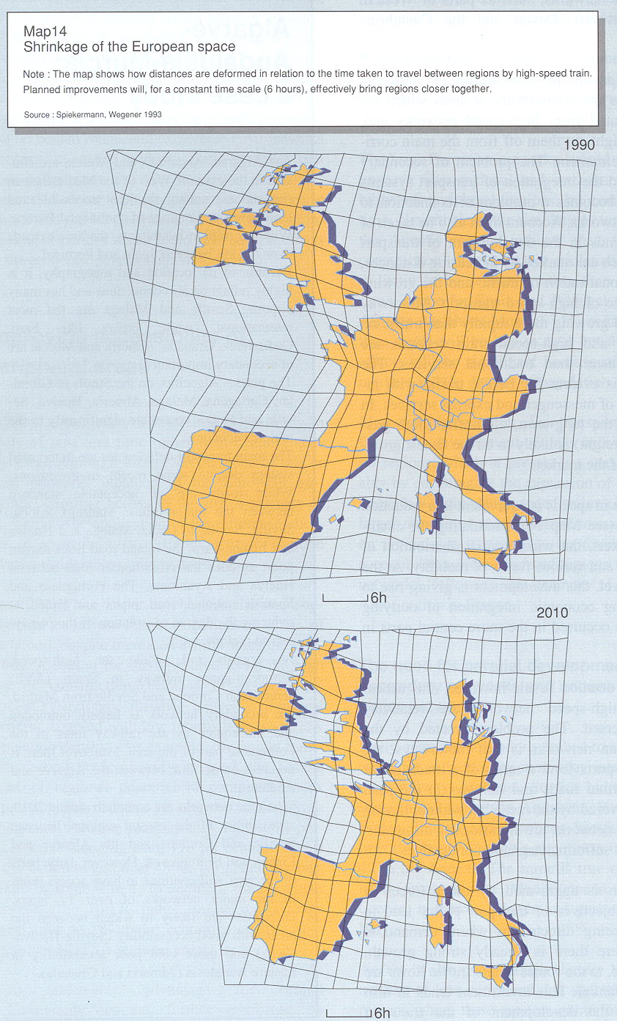
Figure 1: Shrinking Europe (CEC, 1994)

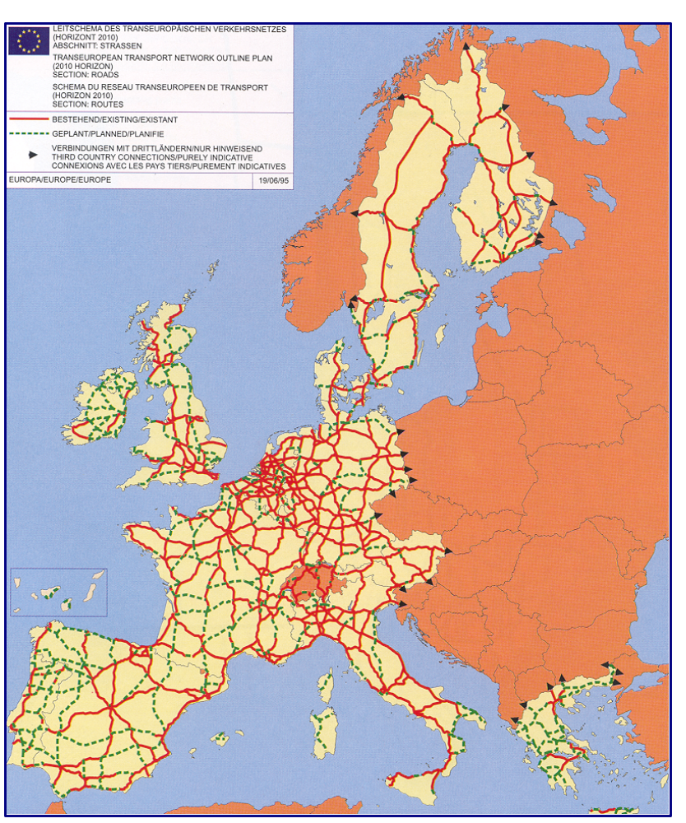

Figure 2: The trans-European network road outline plan (CEC, 1995).

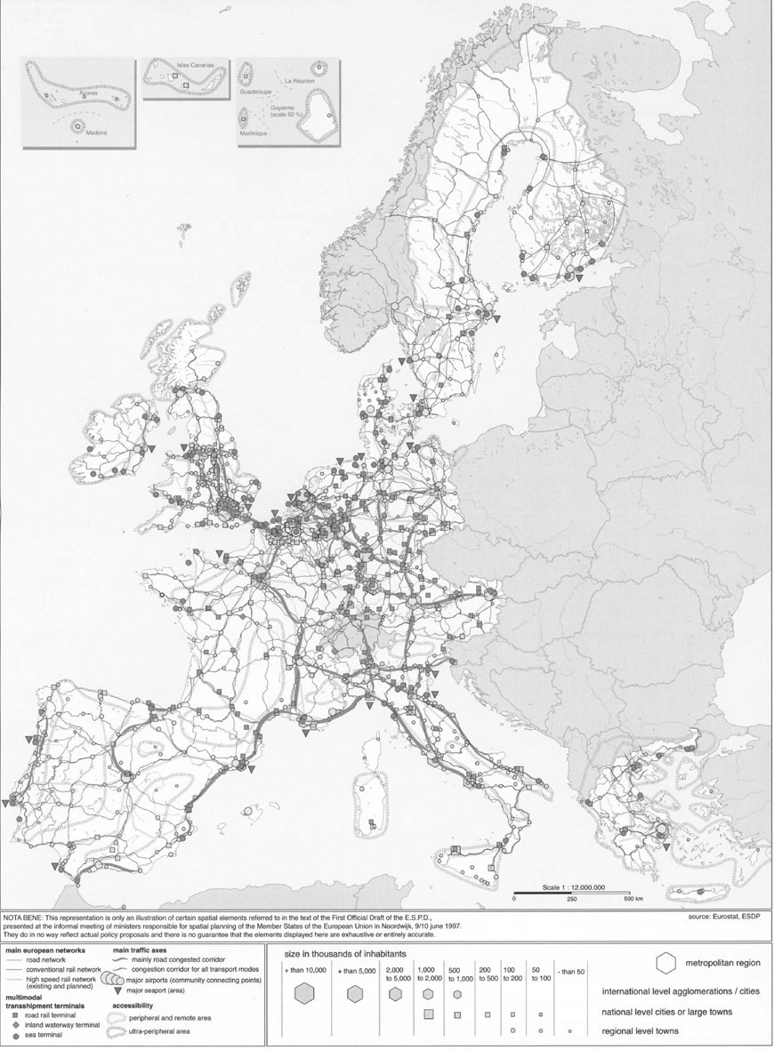

Figure 3: Accessibility, infrastructure and transport, ESDP Noordwijk version (CSD 1997)

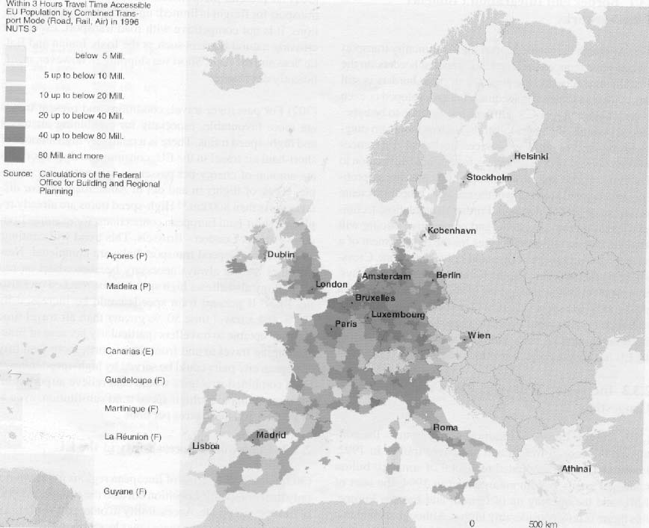

Figure 4: Accessibility, ESDP Potsdam version (CSD 1999:70)

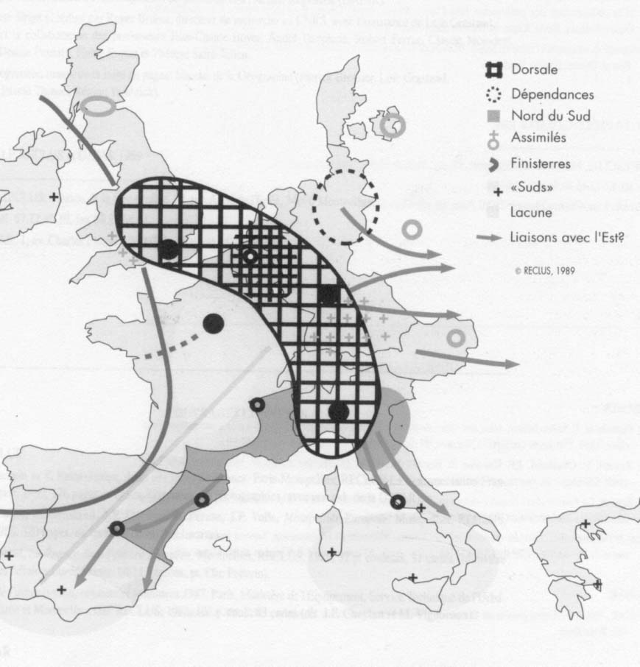

Figure 5: The ‘Blue Banana’ (Brunet 1989)

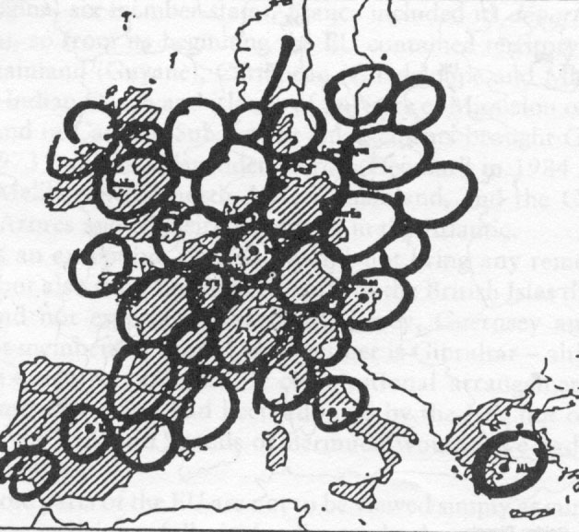

Figure 6: The Europe of Grapes (Kunzmann & Wegener 1991, here from Williams 1996b: 96)

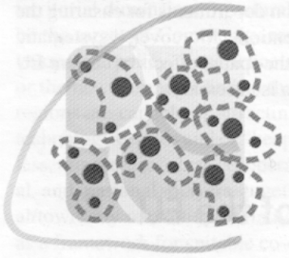

Figure 7: Imagining polycentricity (CSD 1999)

The quotes from policy actors used in this paper are drawn from Richardson, 2000.
The Committee on Spatial Development (CSD) is the intergovernmental group of senior civil service officers from the member states that drafted the ESDP (see Faludi & Waterhout 2002 for a detailed account of the institutional history of the ESDP).
As an illustration of how this particular metaphor has stuck in the minds of European politicians we will make a small contribution to the increasing number of ‘folk narratives’ about the Blue Banana. Supervising a student project, one of this paper’s authors read a number of interview transcripts conducted by the students in question. One was particularly interesting, as it was with the former Danish Minister of the Environment (and planning). In an interview he explained very frankly how his civil servants had shown him a map of Europe picturing the development banana going to the ‘wrong side’ of Denmark. And the minister said; ‘If you see something like that, it is your obligation to straighten up that banana’.
The Study Programme (SPESP) is set up as a Pilot Action under ERDF (’Structural Fund’) Article 10.

